NIGERIAN RED CROSS SOCIETY
NATIONAL HEADQUARTERS
ABUJA
DISASTER MANAGEMENT PROGRAMME ANNUAL REPORT FOR 2012

The Nigerian Red Cross Society has moved steps ahead with timely response by our trained volunteers in the branches. We have continued as the first responder in most emergencies across the country. The arrival of the Field Assessment and Coordination Team (FACT) has supported in profiling the National Society with the conduct of the rapid assessment and the implementation of the Plan of Action of the 2012 Flood Appeal (MDRNG014).

The profile of the NS has greatly risen in recent time. This has attracted a lot of interest in the NS by all responders and has exposed the competence of NRCS in Emergency Management. If this opportunity is properly harnessed by the Governance and Management of NRCS, the NS will have a turnaround in its fortune for years to come.

FUEL SUBSIDY REMOVAL
The Federal government announced on January 1st 2012 an increment in the pump price of petrol (PMS) and as a result, there were protests and strike by the Nigerian Labour Congress in different parts of the country with Kaduna, Kano, Lagos, Oyo and the FCT being more tense than other states. Consequently, it resulted in about 596 injured and 30 dead. The NRCS National Headquarters responded by putting branches on alert and monitored the situation until the strike was called off. The ICRC supported the National Society with communication support for the branches and also pre-stocked dressing kits in three branches of Borno, Gombe and Kano. Part of these prepositioned items were utilised during the response.

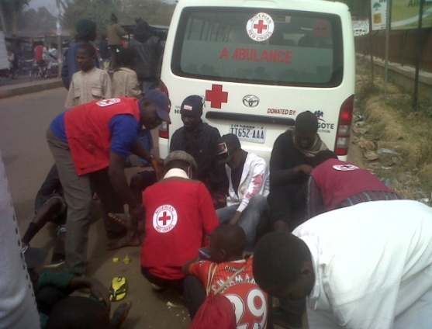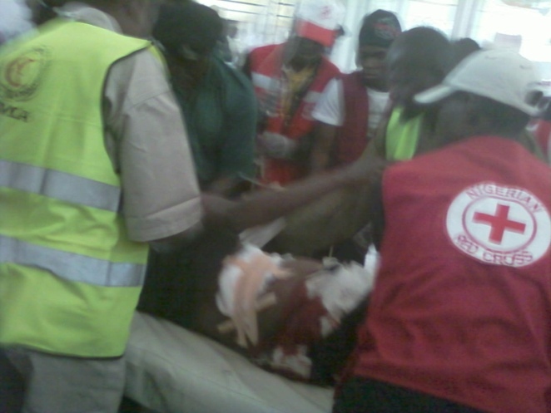
NRCS volunteers at work

GUBERNATORIAL ELECTIONS
The Supreme Court of Nigeria nullified the gubernatorial election in 5 states of- Adamawa, Bayelsa, Cross River, Kogi and Sokoto and new date for elections were re-scheduled. During the elections, all affected branches were placed on alert to monitor the situation so as to provide humanitarian assistance when needed.

BOKO HARAM INSURGENCE
The Nigerian Red Cross Society has with the support of the ICRC continued to support people affected by the explosions and gunfights as a result of the insurgence in Borno, Niger,Yobe, Kano, Adamawa, Taraba, Kaduna, Bauchi, Plateau and Gombe states.

DANA PLANE CRASH
On the 3rd of June 2012, at approximately 3:43pm, a Dana plane crashed into a residential area while attempting an emergency landing in Lagos, killing all 153 passengers and crew on board. The crash site was in a heavily populated urban area and resulted in the death of at least 4 persons who were inside the buildings at the time of the crash, bringing the total number of deaths to 157 people, and 6 injured.

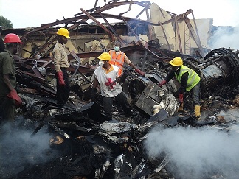
Red Cross volunteers and other stakeholders at the Dana plane crash site

The incident left family members of the affected people and residents of the area traumatized. The Nigerian Red Cross Society Lagos State Branch administered First Aid and helped to evacuate the affected population and with the support of the International Federation of Red Cross and Red Crescent Societies also provided non-food items and psychosocial support training to NRCS volunteers and staff and the affected population. The Psychosocial support to those affected has continued in partnership with the University of Lagos.

RELIEF MATERIALS FOR DANA CRASH VICTIM
RCS volunteers evacuating dead bodies
DESCRIPTION OF ITEMS  Mattresses  Bar Soap  Kitchen Sets  Blankets  Mosquito Nets  Aqua tab  Detergents  Stoves  Clothing  Bucket  Jerry can  Fumigants, Disinfectant, Sanitizer  Water Guard | QUANTITY (IFRC)  300pcs  80 cartons  150pcs  4 bales  4 bales  5 cartons  300kg  150pcs  1 big bale  300pcs  300pcs  1  20 cartons

NIGERIA 2012 FLOODS
Torrential rainfall and the water released from dams on the Niger and Benue Rivers led to the worst flooding in over 40 years. The Floods commenced in the first two weeks of September after the flash floods of July in Jos, Plateau state. With states bordering the Rivers Benue and Niger being the most affected, the floodwaters moved into the Delta area in the south. While flood waters in the states upstream of the River Benue, such as Adamawa, Plateau, Taraba and Benue has subsided, satellite imagery shows the areas along the river downstream are still much wider than in previous years.

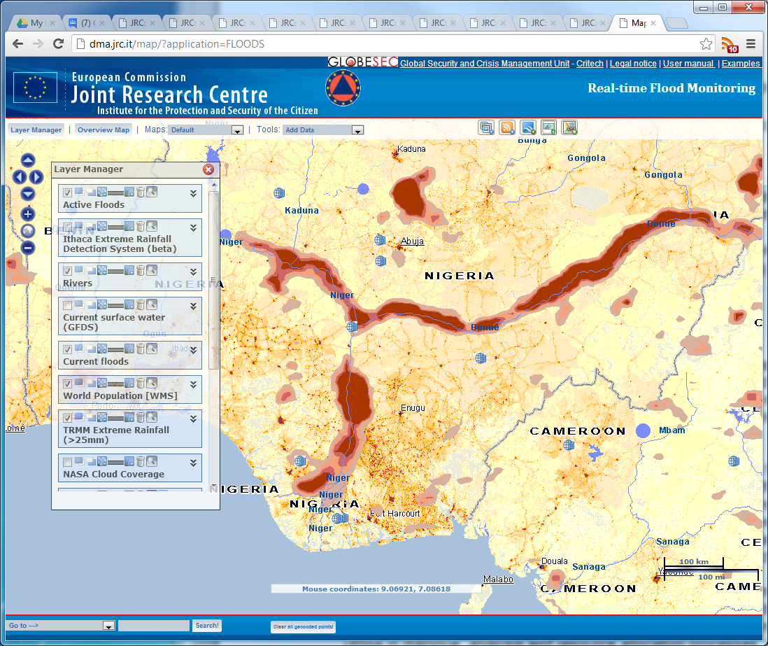
Satellite Imagery of Flood Path
The Nigerian Red Cross Society staff and volunteers in the affected branches responded with First Aid/evacuation and camp management in the affected states. The National Headquarters provided Non Food Items to 7 branches from its prepositioned Non Food Items.

Branch | Division | #s | Quantities | Activities
Adamawa | Girei, Yola South, Yola North, Numan | 304 families | Blankets 608, Buckets 304, Mats 608, Soap 1,200, Shelter Kits 100, Kitchen Sets 100, Tarpaulins 200 and Jerry cans: 200 | Camp Management, Health , Psychosocial support and Hygiene Promotion
Benue | Agatu, Guma, Logo | 60 families | Blankets 300 , Buckets 100, Mats 100, Soap 600, Shelter Kits 40, Kitchen sets 40, Tarpaulins 80, Jerry cans 100 and Second hand clothing 3 bags | Psychosocial support, Camp Management and Hygiene Promotion
Jigawa | Dutse | 50 families | Blankets 100, Mats 100, Mosquito nets 100, Hygiene kits 100, Kitchen sets 20, and second-hand clothing 2 Bags | Social Mobilization and Hygiene Promotion
Katsina | Mai’addua | 50 families | Blankets 100, Mats 75, Mosquito nets 100, Hygiene kits 100, Kitchen sets 20, and second-hand clothing 2 bags | psychosocial support , First aids Services and Information sharing with relevant stakeholders
Kogi | Ajaokuta, Ofu, Koto karfi, Igalamela | 60 families | Blankets 600 , Buckets 100, Mats 100, Soap 600, Shelter Kits 40, Kitchen sets 40, Tarpaulins 80, Jerri can 100 and second-hand clothing 2 bags | Psychosocial Support, Registration of Families affected, Evacuation , Camp Management and Hygiene Promotion
Taraba | Wukari, Ibi, Lau, Ardo-kola, Gassol, Karim lamido | 250 families | Blankets 500 , Buckets 250, Mats 500, Soap 1,080 , Shelter Kits 100, Kitchen sets 100, Tarpaulins 200 and Jerrycan 175 | Camp Management, Psychosocial support, Social Mobilization and Hygiene Promotion

On realizing the overwhelming nature of the 2012 floods, the NRCS National Headquarters asked for surge support from the International Federation of Red Cross and Red Crescent Societies. A Field Assessment and Coordination Team (FACT) was activated and mobilized to support the NRCS in the last week of September, 2012.

The FACT and NRCS conducted a Rapid Assessment in 10 worst affected states of Adamawa, Taraba, Benue, Plateau Niger, Kogi, Edo, Delta, Anambra, and Bayelsa from 6 - 9 October, 2012. The team also determined the immediate health needs of the IDPs, as well as available human and personnel resources in the most affected camps and communities in the targeted 10 states. The analysis of the results -summarized in the table below - is the basis as to what should be the goals and objectives in the intervention. Methodologies used in the rapid assessment include: focus group discussions; individual IDP, key informant and volunteer interviews, as well as secondary data collection.

Summary of NRCS Rapid Assessment Data
State | LGAs | # Affected | # Displaced | # Dead | # Injured | # Missing | # of Camps | # of camp residents | # Homes destroyed  /severely damaged
Adamawa | 6 | 20544 | 15879 | 24 | 233 | 0 | 11 | 5147 | 5740
Taraba | 6 | 15193 | 12440 | 3 | 23 | 0 | 15 | 8058 | 3344
Plateau | 2 | 2096 | 1645 | 3 | 22 | 0 | 0 | 0 | 329
Benue | 4 | 12420 | 7801 | 5 | 5 | 1 | 8 | 5992 | 2183
Kogi | 9 | 72725 | 30709 | 19 | 314 | 1 | 84 | 28764 | 12452
Niger |  | 9935 | 1789 | 32 | 76 | 0 | 3 | 1030 | 278
Edo | 3 | 54269 | 39602 | 10 | 178 | 0 | 13 | 30855 | 1854
Anambra | 10 | 64487 | 43350 | 1 | 1 | 0 | 3 | 43134 | 621
Delta | 8 | 52421 | 29635 | 18 | 15 | 0 | 12 | 27264 | 0
Bayelsa | 8 | 118601 | 73917 | 1 | 0 | 0 | 12 | 73917 | 0
Rivers
Totals | 56 | 422691 | 256767 | 116 | 867 | 2 | 161 | 224161 | 26801
- Source: NRCS Rapid Assessments

The NRCS has been supported by the International Federation of Red Cross and Red Crescent Societies (IFRC) with Disaster Emergency Relief Fund (DREF), Preliminary Emergency Appeal (PEA) and later an Emergency Appeal was launched to support the affected people. There is varying response to the Emergency Appeal by donors within and outside Nigeria.

FACT with NS has initiated contact with several donors, which has resulted in a USD 1 million contribution to the appeal from Shell, Exxon Mobil 500,000 USD, and USAID of US$100,000.
- VERF/WHO Volunteer Emergency Relief: 300 CHF
- Netherlands Red Cross: 96,934 CHF
- Japanese Red Cross: 29,700 CHF
- Canadian Red Cross: 47,285 CHF
- Swedish Red Cross: 130,000 CHF
- Shell Oil Company: 929,670 CHF
- Exxon Mobil 500,000 USD
- French Embassy: 60,455 USD
- Anceture 500,000 NGN
- FCMB Plc 25,000,000 NGN
- Stanbic Ibtc 10,000,000 NGN
- Zumutai Association USA 475,000 NGN
- Mobil Producing Nigeria ltd 2,500,000 NGN
- NLNG 500,000 USD

In-kind donations
- Nestle Nigeria Limited
- Nigerian Bottling company
- News Agency of Nigerian(NAN)
- And other Individuals

The NRCS is the first organization to conduct an assessment of the current situation in Nigeria and has become a reference point for all responders including the National Emergency Management Agency, NEMA, the Interagency Emergency Preparedness and Response Working Group (IA-EPR WG) and the Humanitarian Country Team of the UN (HCT). As a result of interest indicated by a major donor, Shell Petroleum Development Company (SPDC), we have included Rivers state among the targeted branches for response.

The NRCS response to the 2012 flood led to the reinstatement of the IFRC country delegation which was relocated to Abidjan in October 2010 and the Federation Representative has been recruited and posted to Nigeria. The presence of the Federation in country will support the National Society in the area of programmed activities as opposed to the response operation we carry out now.

MOVEMENT COORDINATION
The movement coordination has been weak due to the absence of IFRC in the country but with the current presence of the IFRC with a new Head of delegation and office in Abuja there will be monthly coordination meeting among the ICRC, IFRC and the National Society to bring about a more coordinated approach to the Movement activities in Nigeria. There has also been cooperation between the National Society WATHAB focal person and the IFRC and ICRC WATHAB delegates to carry out a more effective and efficient water and sanitation activities in the country. The ICRC HoD has been supporting the NRCS in all areas of this operation. Our request for logistical support was answered with a 4x4 vehicle for 4 weeks and has been extended for some months with the promise of additional vehicles coming to the NS.

VALUE ADDED
The flood operation has presented to the NRCS an excellent opportunity to redeem its image and continue to provide a lead role amongst emergency management stakeholders. This has won the confidence of Participating National Societies (PNSs) that have already indicated willingness to come back and continue supporting NRCS in programming.

RESTORING FAMILY LINKS
As part of its activities, the RFL unit of the NRCS carried out RFL assessment during the Dana plane crash and the floods affecting the 11 targeted worst affected states. A few successes were recorded with clarifying the fate of those reported missing, while several unaccompanied minors were reunited with their families especially with the flash flood in Plateau state in July 2012.

The focal point for the programme was supported by the ICRC to participate in the regional RFL meeting in Dakar where a presentation of RFL activities in Nigeria was made. The presentation highlighted the challenges faced by NRCS in providing RFL services and the general lack of awareness of the services and this has led to an offer by the regional delegation to conduct training in Nigeria soon.

Three field visits to work on RFL cases occasioned by migration was conducted to the branches of Edo, Lagos, Oyo, Ogun, Anambra, Enugu and Imo with the support and participation of the ICRC. The NRCS NHQ on its part supported the unit in terms of communication support and internet to enable speedy disposition of request from originating National societies. In all 102 tracing request and Red Cross Messages were received and dealt with while 26 RCMs related to military service in the United States were received and sent to the American Red Cross Society. 57 disasters related RFL cases were reported by various affected branches.

PARTNERSHIP
All meetings with external stakeholders over the past months reinforce the same two messages: every entity in emergency management landscape in Nigeria is looking to the Nigerian Red Cross Society to lead the way in response, even well above and beyond its capacity and mandate; and secondly, no other agency or organization is placed and able to react with even half of the speed and capacity with which the NS reacted to the disaster.

All Emergency Management Stakeholders in Nigeria are now willing to partner with the NRCS. NEMA has signed an MoU with the NS and donated a fully equipped ambulance to herald this partnership.

Alhaji Danyaro Ali Yakasai
National DM Adviser

