NIGERIAN RED CROSS SOCIETY
NATIONAL HEADQUARTERS
ABUJA

HEALTH AND CARE DEPARTMENT 2012 TO FIRST QUARTER 2013 REPORT
Health and Care is one of the Nigerian Red Cross Society’s core programmes
Following the Strategic Development Plan (SDP) 2011 - 2013 of the Nigerian Red Cross Society (NRCS), the health and care department adopted the following programs in its 2012 Plan of action. Namely;
- HIV/ AIDS
- CBH&FA ( maternal, neonatal and child health (immunizations)
Health in emergencies)
- VOLUNTARY NON REMUNERATED BLOOD DONOR RECRUITMENT
- WATSAN

Overall Health Programme Goal
The overall goal of the Nigerian Red Cross Society’s Health Programme is to reduce morbidity and mortality by strengthening the capacity of the vulnerable people in their daily lives and enabling them to address their priority health problems.

HEALTH IN EMERGENCIES
The focus of health in emergencies is on prevention and response to epidemics and prevailing health issues, especially those that affect the most vulnerable (women and children, rural and urban communities)

- The NRCS health and care department with support from the IFRC delivered assistance to communities affected by Lassa fever in Ebonyi, Edo and Nasarawa states on the 13th Feb. 2012 was closed on 25th May 2012, having reached 21,000 households (81,461 people) which is about 4% above the targeted population. Collectively, the assistance delivered contributed to alleviating the living conditions of the community members reached.

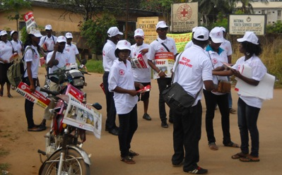
Activities carried out
- Recruitment and Training of 282 NRCS community volunteers to carry out Rapid community assessment to determine the risk factors and the gaps left by other partners in control of Lassa fever.
- 300 volunteers were trained on Lassa fever overview and vector control, good hygiene, water purification, sanitation, hospital referrals and they were equipped with Epidemic control kit/module
- The volunteers carried out community sensitizations and campaigns on prevention of Lassa fever, good hygiene, water purification, sanitation and hospital referrals.

Achievements
- The National Society continued to play a major role in health emergency response in Nigeria
- More Red Cross volunteers’ capacity built on Health epidemics response.

Constraints
Lack of funding to cover more states as the NRCS responded in 3 out of 19 states initially involved.

- The Health and care Department on the 15th December 2012 commenced its activities on the flood intervention in Nigeria, involving 10, out of the affected 23 States. This is supported by the IFRC.
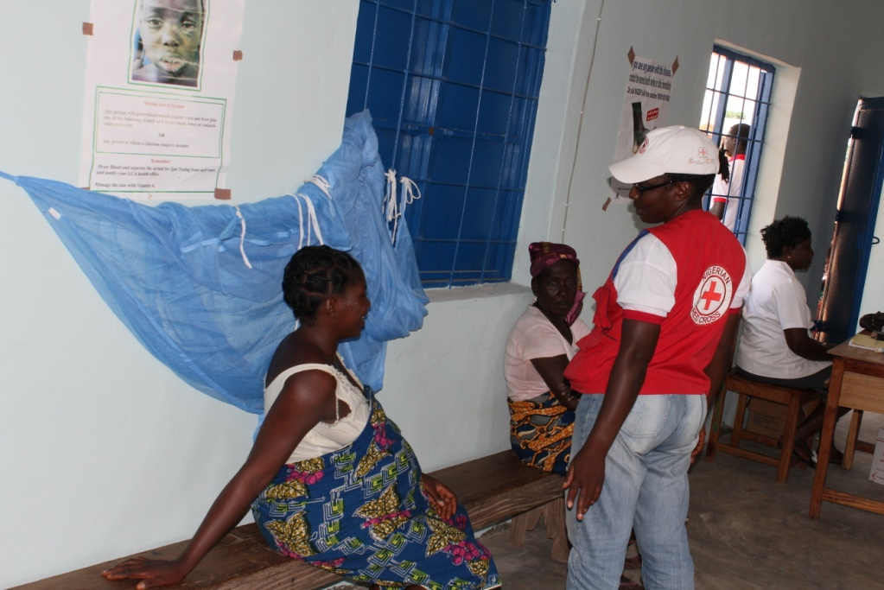

It has so reached a total number of 21,886 people in different communities in the 10 states with following activities:
- Sensitization on Malaria Prevention and control.
- Households group sensitization on disease prevention and health promotion
- Sensitization on diarrhea diseases in children, possible causes, preventive measures and treatment using Oral Dehydration Therapy.
- A complete demonstration on the mode of application of ORS and how to improvise in the absence of ORS using our household iodized SALT and SUGAR Solution in appropriate quantity.
- Hand washing and its importance in disease prevention.
- Monitoring of relief distribution of Mosquito nets as three (3) each was given per household.

Some of the challenges encountered so far are lack of health facilities, pharmacy, health provider or trained health workers in some communities.
This intervention is presently ongoing.

Community Based & First Aid (CBH&FA)
The CBH&FA programme commenced since 2010 and was designed to support basic health needs provided by the government, it comprises basic health care, social mobilization for immunisation and control, malaria prevention, community-based first aid, health in emergencies etc.

- As a result of reports coming from members of Kuyizhi community as well as from the Daily Trust Newspaper, the NRCS Health and Care Department in synergy with the Disaster Management Department with support from the NRCS National Headquarters carried out various activities aimed at improving resilience and capacities of people of Kuyizhi community (Kuje Area Council) regarding risk reduction particularly those related to water and health. About a thousand people (33 Households) were reached with the following activities:

Activities
- Education on safe water and distribution of water treatment chemicals.
A training session was conducted to teach community members on how to make water safe for drinking. Part of the topics taught in the session was methods of household water purification which include filtration, sedimentation, boiling and chlorination.

The correct use of Aqua tab for household water treatment was demonstrated to the community members and 3,060 numbers of Aqua tabs (Six months supply) were then distributed to all households in the community.

- Malaria prevention and distribution of LLINs
Community members were educated on the cause of malaria, its prevention and importance of seeking medical help for malaria treatment. 50 Long Lasting Insecticide Treated bed nets (LLINs) were distributed to children (0 - 5 years), nursing mothers, pregnant women and the elderly in the community. Proper use of LLINs (hanging and care of the net) was also demonstrated to the community members.

- Trainings of Mothers on Nutrition
Women in the community attended a training session on nutrition. They were taught the importance of good nutrition for pregnant and nursing mothers, exclusive breastfeeding of newborn for six months, introduction of weaning diet after six months, good nutrition for children and adolescent females. There was demonstration on different classes of food and how they can be combined to make balanced diet. Mothers were taught how to make weaning cereal using locally available food.

- Management of Diarrhea and distribution of ORS
The training session on management of diarrhea was well attended by both men and women in the community. Topics treated under this session include diarrhea, signs and symptoms of dehydration, preparation of ORS, how to administer ORS, home remedies for management of dehydration.

340 sachets of Oral Rehydration Salt (ORS) were distributed to mothers in the community.

- Shovels and wheel barrows were given to the community to support their communal work and waste management.

- First Aid training for 20 community members
- Community Health Centre
Kuyizhi community members jointly constructed a 3 – bedrooms Health Centre while the NRCS donated hospital equipments to the community. NRCS formally commissioned and handed over the community clinic to Kuje PHC on 10th October, 2012 and the Director; PHC Kuje Area Council assigned two health personnel to man the community clinic.

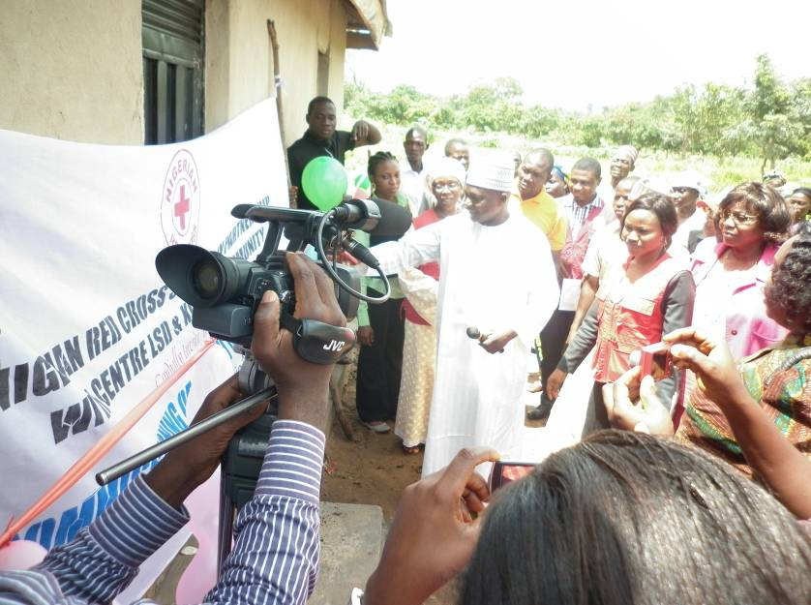
Achievements
The NRCS achieved increased visibility in its interventions.

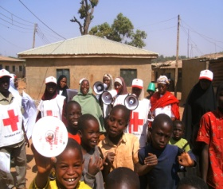
- The NRCS Health and Care Department with support from the IFRC carried out social mobilization activities in Kaduna, Niger and Bauchi States, using its mother’s club unit and other volunteers, from the 14th to 18th December 2012 at 5 LGAs in each branch and 100 wards per LGA. A total number of 126, 478 where reached.

The volunteers made a comprehensive list of non compliant communities, held meetings with them and the caregivers on behavioral change and the educated them on the importance of polio vaccine and dangers of polio.

Some challenges faced are that of non compliance on the part of some of the registered children and some communities where not accessible with vehicles. The recommendations include constant meeting with non compliant households and using electronic media to display to them the effects of polio.

Increasing the number of LGAs and States to be reached.

HIV/AIDS
The IFRC met with UNAIDS early February to discuss on how to meet up with the 15 million people living with HIV/AIDS on treatment come 2015 target set by the UNAID. Based on this target, a gap of 6 million is yet to be filled, on further investigation, Nigeria happens to be one of the countries indentified to have large number of PLWHIV not on treatment, based on high prevalence rate Cross River and Benue States where chosen as pilot states to intervene.

The NRCS Health and Care Department together with the IFRC heath team, has just concluded a rapid assessment of the these two states, with the aim of identifying the gaps and challenges faced by the caregivers/stakeholders and thereby plan on where and how to intervene.

RAMP (Rapid Mobile Phone Based) Survey Tool Kit.
The IFRC recently introduced a new innovative for organizations and other partners to conduct health surveys at reduced costs, in a timely fashion and with limited external technical assistance.

This approach was tested in Cross River in 2011. Malaria was chosen to test the innovative approach with surveys designed to find out about net coverage following a mass distribution of long - lasting insecticide - treated nets (LLINs).
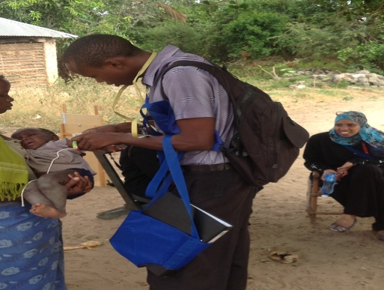
The NRCS health team visited Kenya on the 3rd of February 2012, to witness first hand on how RAMP was rolled out. It is planning a day orientation meeting in Delta State in collaboration Roll back malaria (FMOH) with support from the IFRC.

REMI BABALOLA RED CROSS CLINIC
On the 17th November 2012 the NRCS health team and the Vice president went to Ibadan were the Remi Babalola Red Cross Clinic was officially commissioned by the Hon. Minister of the health in Ibadan Oyo State, consequently on the 21st February 2013 the inaugural board meeting of the Remi Babalola Red Cross clinic took place at the board room of the clinic in Gbagi, Ibadan with the other stakeholders in attendance - UCH, Remi Babalola Initiative, and Representatives of the host LGC, Police, Federal Road Safety Commission, FMoH and Nigerian Security & Civil Defence Corps also attended the meeting.

Also the Abeokuta Red Cross clinic has been commissioned, board constituted and is operational.

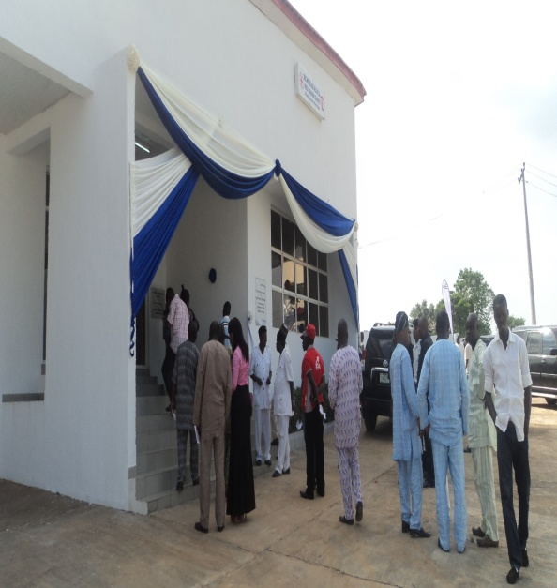

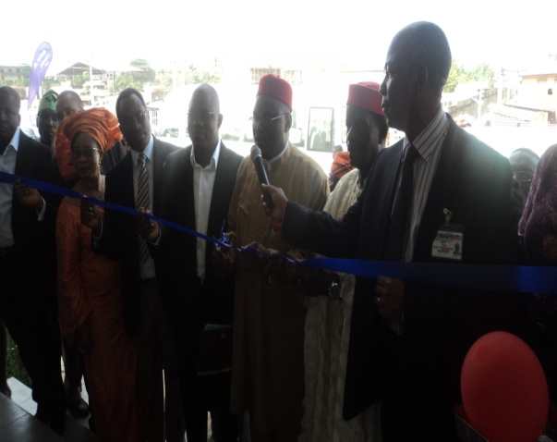

PROSPECTS:
- The NRCS health team with support from the IFRC health team is working on developing a proposal on Integrated Case Management on malaria to be funded by USAID.

- The NRCS Health and Care Department is presently developing a proposal for Bill and Melinda gates foundation in support of its eradication of polio campaign. This process is facilitated by the IFRC.

- The NRCS health and Care Department is concluding on its assessment report to work with the UNAID on reaching its targeted 15 million PLWHIV on treatment goal. This is also facilitated by the IFRC and technical inputs from the IFRC health team.

